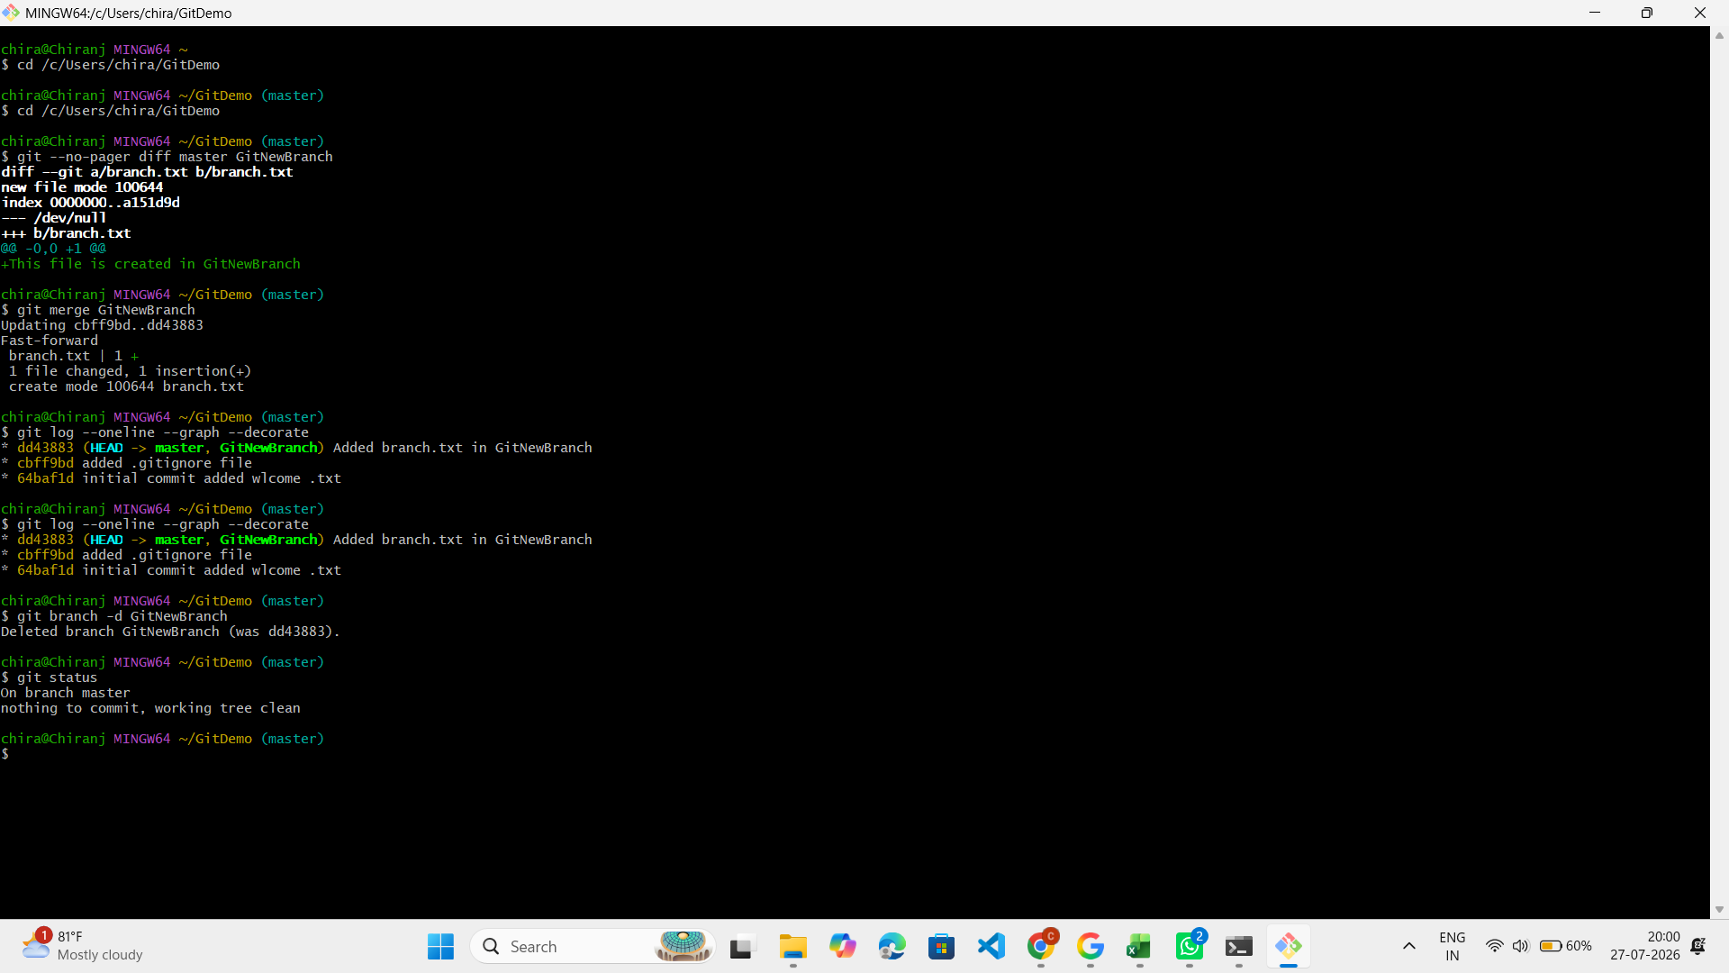# Go to your Git repository
cd /c/Users/chira/GitDemo

# Check current branch
git branch

# Create a new branch
git branch GitNewBranch

# List all local and remote branches
git branch -a

# Switch to the new branch
git checkout GitNewBranch

# Create a new file
echo "This file is created in GitNewBranch" > branch.txt

# Verify file
ls

# Add the file
git add branch.txt

# Commit the changes
git commit -m "Added branch.txt in GitNewBranch"

# Check status
git status

# Switch back to master
git checkout master

# Show differences between master and branch (without opening Vim)
git --no-pager diff master GitNewBranch

# (Optional) Visual comparison using P4Merge
git difftool master GitNewBranch

# Merge the branch into master
git merge GitNewBranch

# View commit history
git --no-pager log --oneline --graph --decorate

# Delete the merged branch
git branch -d GitNewBranch

# Verify status
git status

